INTRODUCTION

“Follow the way of love and eagerly desire gifts of the Spirit…”
(1 Corinthians 14:1, NIV, emphasis added)

- God has called us to eagerly desire (from the Greek word zēloō, meaning to pursue with zeal) the spiritual gifts He gives, but this call is in the context of walking in His love (agape) as defined in 1 Corinthians 13.
“Now about the gifts of the Spirit, brothers and sisters, I do not want you to be uninformed.”
(1 Corinthians 12:1, emphasis added)
- It’s God’s desire that we not be ignorant (agnoeō) of the gifts that He gives us, but to grow in them and understand what they are, and that it is His Holy Spirit who releases them.

- Previous sessions’ notes are available at evidentlife.org/eagerlydesire

These gifts all flow from the Holy Spirt, who is God (2 Cor. 3:18), but how do we connect with and remain in the Holy Spirit who gives these gifts?

- THE TABERNACLE – GOD’S DWELLING

  - Under the Old Covenant, God commanded Moses to have His people build a very specific Tabernacle so that God could dwell among them. Exodus 25-31 & 35-40 detail the plans given to Moses by God, and the construction of this dwelling place that God commanded them to build for Him so that His manifest presence could dwell among them.

⁸ And let them make me a sanctuary, that I may dwell in their midst. ⁹ Exactly as I show you concerning the pattern of the tabernacle, and of all its furniture, so you shall make it.
(Exodus 25:9)

  - Jesus, and the disciples after Him, teach us that all the Law, the Prophets, and the Psalms testify to Jesus Christ and the New Covenant that was being established in Him (Lk. 24:27,44; Jhn. 1:45, 5:46; Acts 24:14, 28:23; Rom. 3:21). We can therefore now learn and gain understanding from God in all that is contained within the Scriptures (including the Old Testament) into what it looks like to live in this New Covenant, including from the Tabernacle.
⁵ They (the earthly priesthood, in the earthly Tabernacle) serve a copy and shadow of the heavenly things. For when Moses was about to erect the tent, he was instructed by God, saying, “See that you make everything according to the pattern that was shown you on the mountain.” ⁶ But as it is, Christ has obtained a ministry (priesthood) that is as much more excellent than the old as the covenant he mediates is better, since it is enacted on better promises. (Hebrews 8:5-6, emphasis added)

  - When King David desired to build God a more permanent physical dwelling in Jerusalem (the Temple that Solomon eventually built), modeled after the Tabernacle, God spoke to David through a word and vision to the Prophet Nathan. This prophecy had a partial fulfillment in Solomon, but this was ultimately about the New Covenant and the spiritual house in which God would dwell that was to come in Christ, the Son of David.
⁴ “Go and tell my servant David, ‘Thus says the Lord: It is not you who will build me a house to dwell in… ¹¹ When your days are fulfilled to walk with your fathers, I will raise up your offspring after you, one of your own sons, and I will establish his kingdom. ¹² He shall build a house for me, and I will establish his throne forever. ¹³ I will be to him a father, and he shall be to me a son. I will not take my steadfast love from him, as I took it from him who was before you, ¹⁴ but I will confirm him in my house and in my kingdom forever, and his throne shall be established forever.’” (1 Chronicles 17:4 & 11-14, emphasis added)
  - We learn from the Apostle Peter that in this New Covenant, we in Christ are ourselves being built up as a spiritual “tabernacle” and are a priesthood unto God. Called to bring spiritual sacrifices and enter His presence through Christ.
⁴ As you come to him (Jesus), a living stone rejected by men but in the sight of God chosen and precious, ⁵ you yourselves like living stones are being built up as a spiritual house, to be a holy priesthood, to offer spiritual sacrifices acceptable to God through Jesus Christ.
(1 Peter 2:4-5)
  - The Apostle Paul also reminds us multiple times in his exhortations to the church in Corinth that we ourselves are the temple of the Holy Spirit in Christ, a dwelling place for God’s presence.
¹⁶ Do you not know that you are God's temple and that God's Spirit dwells in you?... For God's temple is holy, and you are that temple. (1 Corinthians 3:16-17, emphasis added)
¹⁹ Or do you not know that your body is a temple of the Holy Spirit within you, whom you have from God? You are not your own (1 Corinthians 6:19., emphasis added)

  - Since we know that part of our identity in Christ is that we are a spiritual house, a temple, a tabernacle, and dwelling place for God, we can learn more about our identity and function as a spiritual priesthood by looking at the foreshadowing of the prophetic Tabernacle Moses built at God’s command.

- OVERVIEW OF THE TABERNACLE MODEL – GATES AND COURTS, ENTERING IN
  - The Tabernacle where God’s manifest presence and glory dwelt was composed of two main sections: an Outer Court, and an Inner Court. Each of these had a gate or door through which one would need to enter in order to draw near to God.

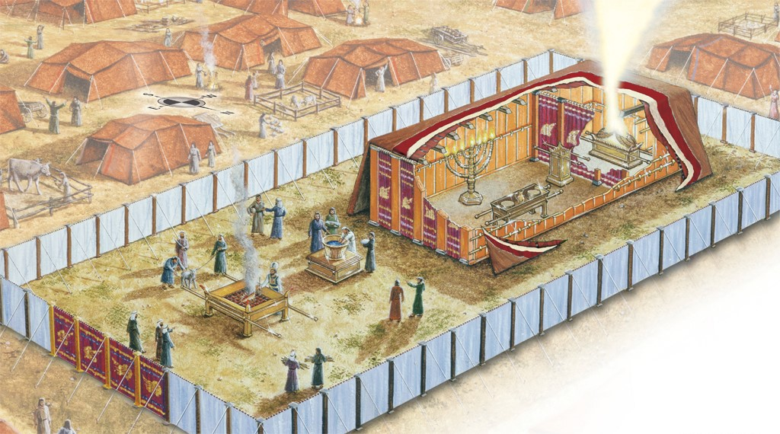
Image Ref: Tabernacle PowerPoint by Rose Publishing, ISBN: 978-1-59636-245-1

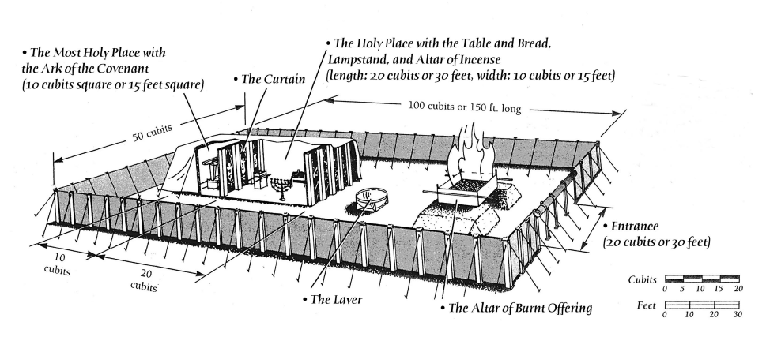
Image Ref: https://www.biblegateway.com/blog/2014/07/experience-the-tabernacle-an-interview-with-jeanne-whittaker/

  - Each of the courts had a gate, or door, through which one would enter. The entryway was made of fine linen curtain colored blue, purple, and scarlet (which were all precious dyes) with cherubim woven into them. These entryways symbolized Christ Jesus, who is the Way to the Father.
⁶ Jesus said to him, “I am the way, and the truth, and the life. No one comes to the Father except through me.” (John 14:5-7, emphasis added)
⁹ I (Jesus) am the door (or gate). If anyone enters by me, he will be saved and will go in and out and find pasture. (John 10:9, emphasis added)
    - Blue – said to be symbolic of the heavens, and Jesus came from heaven to earth, “veiled” in flesh, also the color of the robe that the High Priest wore, showing Jesus’ priesthood (Exodus 24:10, 39:22; John 1, 14, 3:12-13, Heb. 4:14)
    - Purple – said to be symbolic for royalty, a costly dye color worn by royals and kings, speaking of Jesus’ identity as Lord and King (Judges 8:26; Esther 8:15; Lam. 4:5; Ezekiel 23:6; Dan. 5:7, 16, 29; Mark 15:17, 20; Acts 2:36; Philip. 2:9-11; Rev. 17:14)
    - Scarlet – said to be symbolic of blood and was also used in ceremony for cleansing from sin. Jesus’ blood was shed for our forgiveness and cleansing (Lev. 14:4, 6, 49, 51-52; Num. 19:6 Isa. 1:18; Heb. 9:18-20, Rev. 5:9)
    - Cherubim – angelic beings who serve by guarding the way to holy places where God’s presence is (Gen. 3:24, Ps. 99:1, Isa. 37:16, Ezekiel 28:4)
  - God is calling us to draw near to Him (Jas. 4:8), and to enter into His holy presence through His Son, Christ Jesus, the Son of God (Rom. 1:4) and Son of Man (Jhn. 3:13), our Great High Priest, The King of kings and Lord of lords, the sacrifice and atonement for our sins.

- ENTER IN WITH THANKSGIVING AND PRAISE
¹ Make a joyful noise to the Lord, all the earth!² Serve the Lord with gladness! Come into his presence with singing!³ Know that the Lord, he is God! It is he who made us, and we are his; we are his people, and the sheep of his pasture. ⁴ Enter his gates with thanksgiving, and his courts with praise! Give thanks to him; bless his name! ⁵ For the Lord is good; his steadfast love endures forever, and his faithfulness to all generations.
(Psalm 100, emphasis added)

  - Psalm 100 gives us not only a practical exhortation, but a spiritual and prophetic call of how we can enter into God’s presence. When approach God through Jesus with songs of thanksgiving and praise, we begin to enter into His presence. This is why we often begin our gatherings with songs of thanksgiving and praise, not as a “warm-up” for a sermon, but in order that we may draw near to God’s presence together.

  - Notice also that Psalm 100 uses the plural of “gates” and “courts”. We are called to continue with thanksgiving and praise throughout this entire journey of drawing near to God, not just “on the way in”. The Scriptures call us to give thanks and praise in every season of life, and at all times, in order that we might constantly live before Him.
⁸ Oh give thanks to the Lord; call upon his name; make known his deeds among the peoples!
⁹ Sing to him, sing praises to him; tell of all his wondrous works! ¹⁰ Glory in his holy name; let the hearts of those who seek the Lord rejoice! ¹¹ Seek the Lord and his strength; seek his presence continually! (1 Chronicles 16:8-11, emphasis added)
¹ I will bless the Lord at all times; his praise shall continually be in my mouth.
(Psalm 34:1, emphasis added)
¹⁸ …be filled with the Spirit, ¹⁹ addressing one another in psalms and hymns and spiritual songs, singing and making melody to the Lord with your heart, ²⁰ giving thanks always and for everything to God the Father in the name of our Lord Jesus Christ (Ephesians 5:18b-20)
¹⁶ Let the word of Christ dwell in you richly, teaching and admonishing one another in all wisdom, singing psalms and hymns and spiritual songs, with thankfulness in your hearts to God. ¹⁷ And whatever you do, in word or deed, do everything in the name of the Lord Jesus, giving thanks to God the Father through him. (Colossians 3:16-18, emphasis added)
¹⁵ Through him (Jesus) then let us continually offer up a sacrifice of praise to God, that is, the fruit of lips that acknowledge his name. (Hebrews 13:15, emphasis added)
¹¹ And all the angels were standing around the throne and around the elders and the four living creatures, and they fell on their faces before the throne and worshiped God, ¹² saying, “Amen! Blessing and glory and wisdom and thanksgiving and honor and power and might be to our God forever and ever! Amen.” (Revelation 7:11-13, emphasis added)
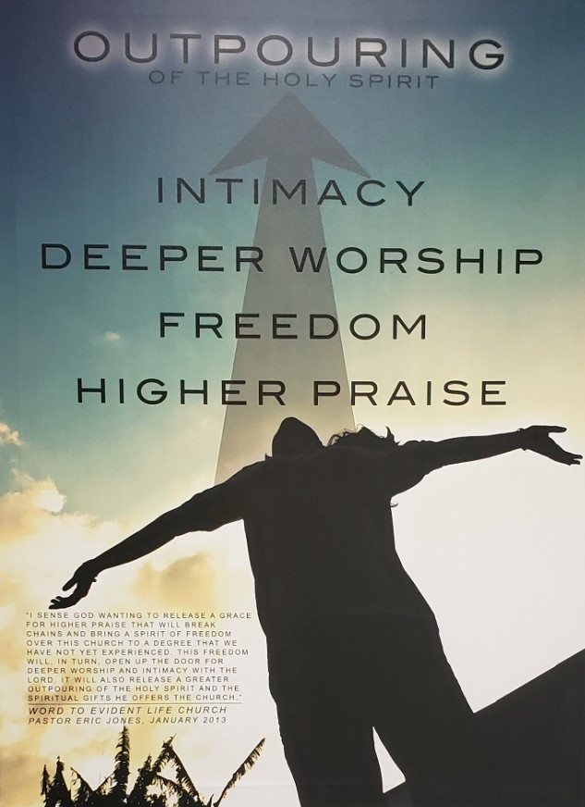
  - In the beginning of 2013, Pastor Eric shared a prophetic word from the Lord for Evident Life Church during the service. This word lines up with the Scriptures, and the model of the Tabernacle that we’re diving into in this study.
“I sense God wanting to release a grace for higher praise that will break chains and bring a spirit of freedom over this church to a degree that we have not yet experienced. This freedom will, in turn, open up the door for deeper worship and intimacy with the Lord. It will also release a greater outpouring of the Holy Spirit and the spiritual gifts He offers the Church”
- Pastor Eric Jones, January 2013

